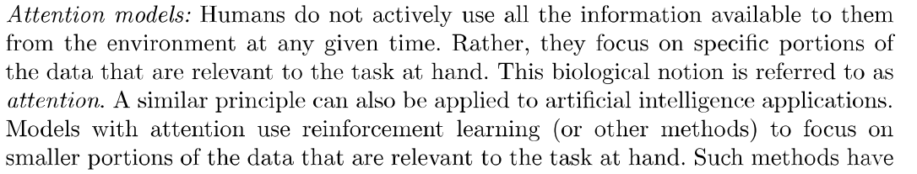

Fig: Resolutions at different regions of Eye

**Recurrent Models of Visual attention**

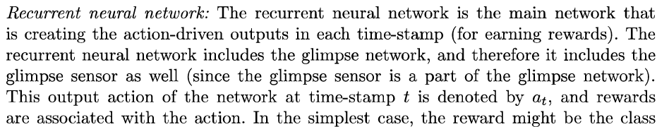

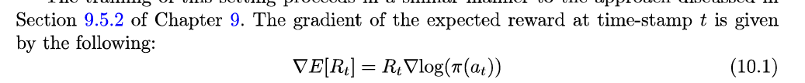

**Attention mechanism for Image captioning**

Fig: Visual attention in Image captioning

**Attention mechanism for Machine Translation**

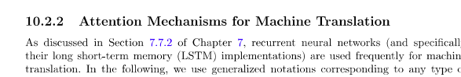

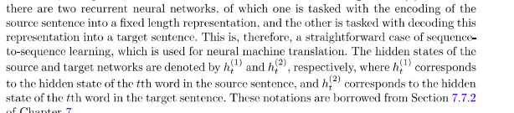

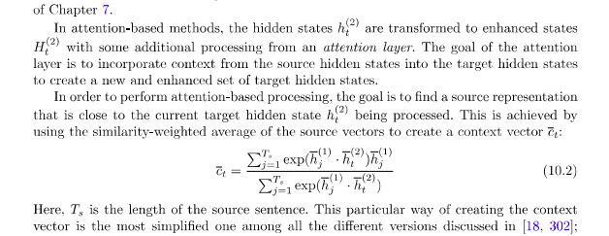

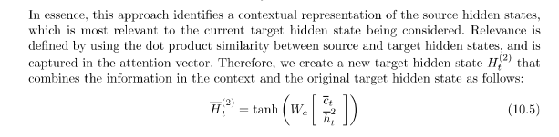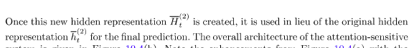

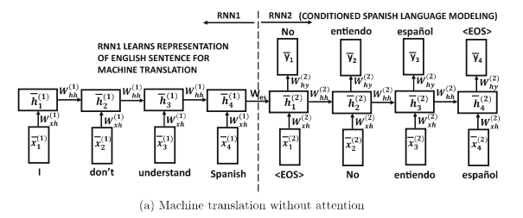

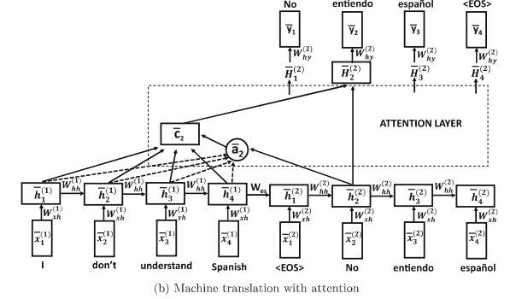

**Neural Turing Machine**

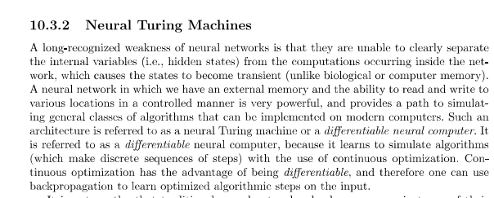

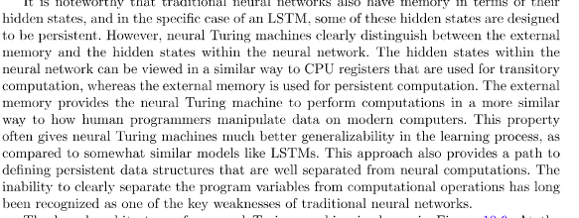

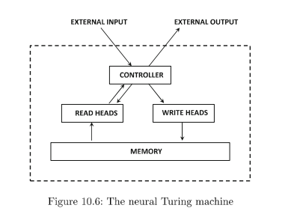

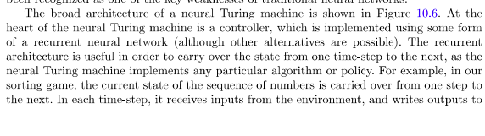

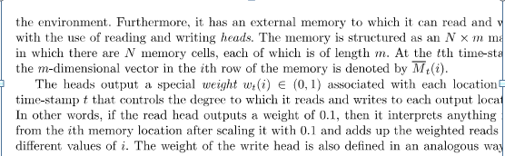

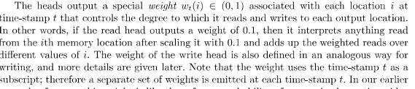

What are the weaknesses of Neural Turing Machines:

(OR)

Differentiable Neural Computer

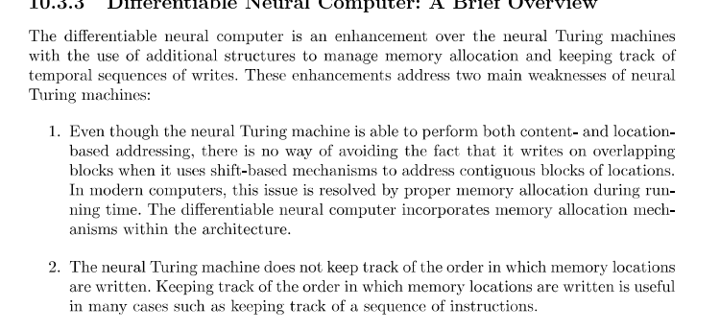

How these two weakness are overcome in Differatiable Neural computer:

1.

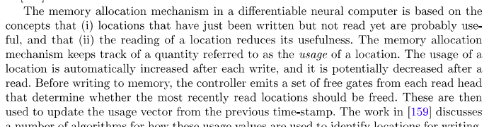

2. 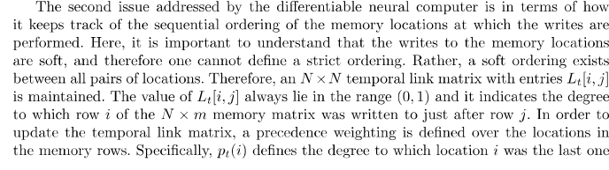

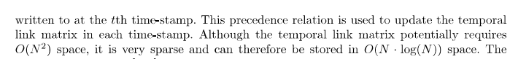

Generative Adversarial Networks (GANs)

Two types of learning models used for creating adversarial Nwtworks are:

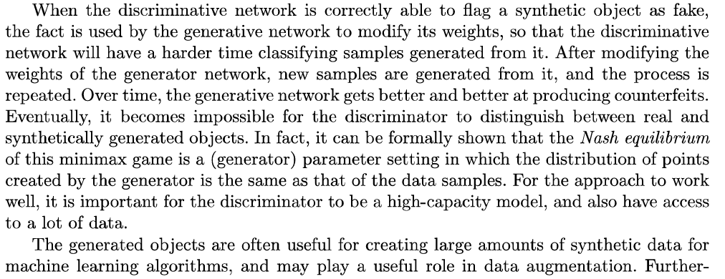

Training GANs

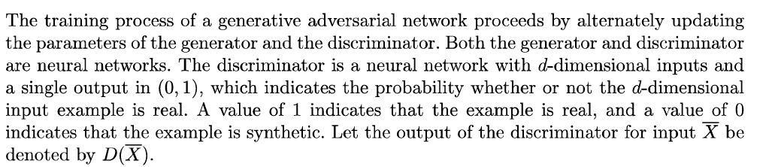



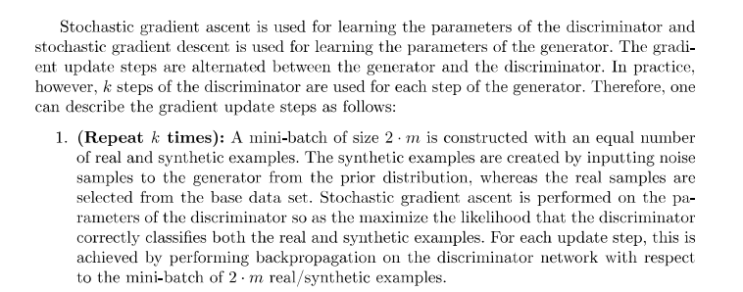

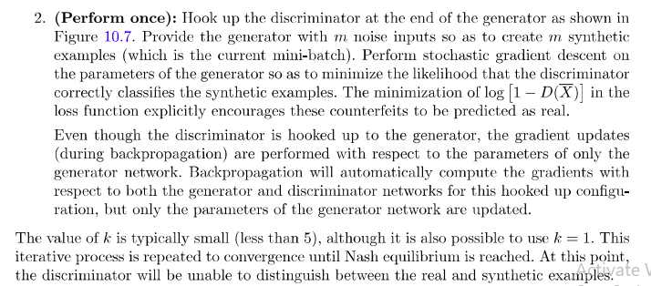

Comparison of Variational Autoencoder and GANS

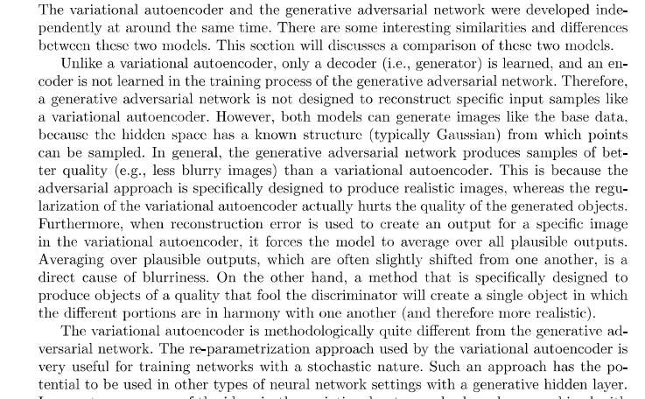

**Using GANS for generating Image data**

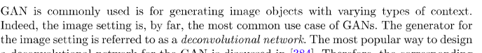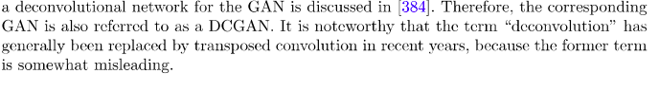

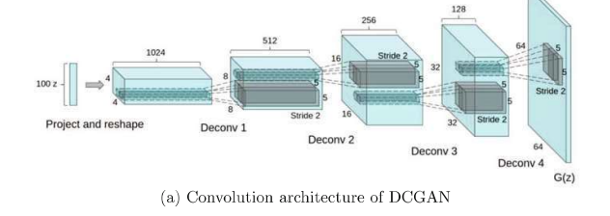

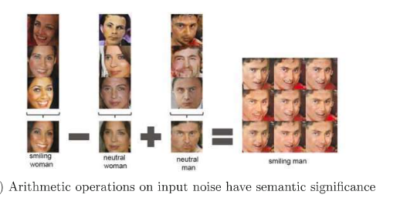

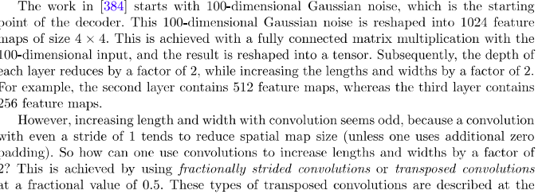

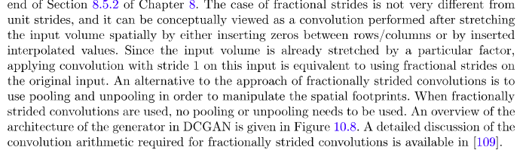

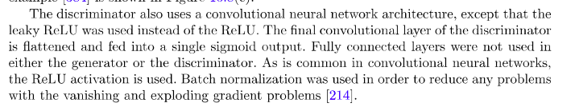

**Conditional Generative Adversarial Networks**

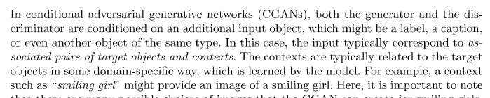

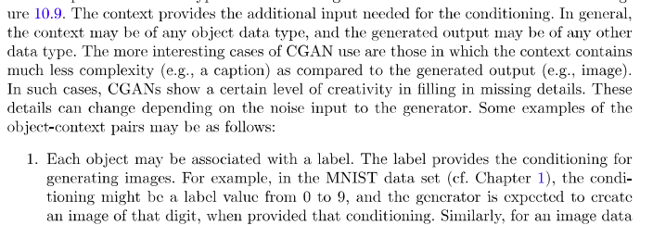

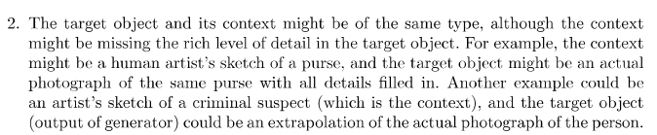

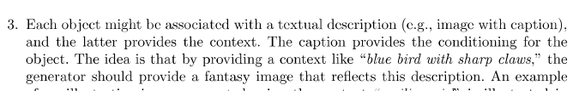

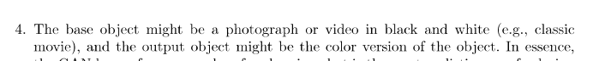

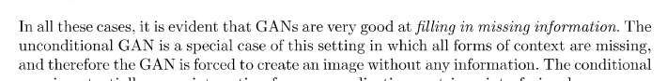

**CGGAN to generate actual photograph from artistic image**

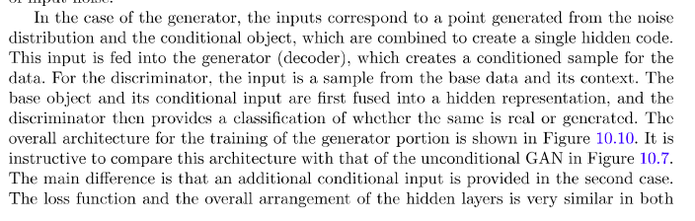

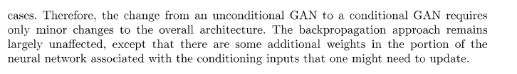

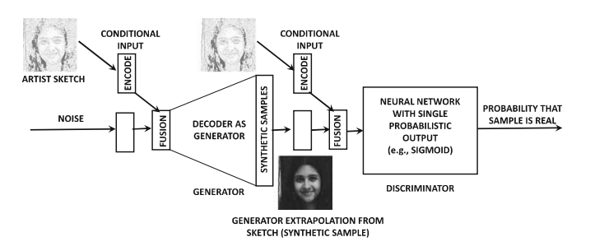

**Competitive Learning**

**In neural networks, weights will be updated to minimize the error.**

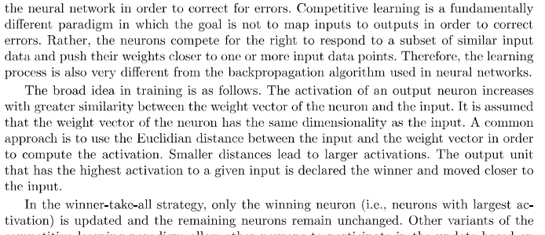

Simple verson of competitivelearning

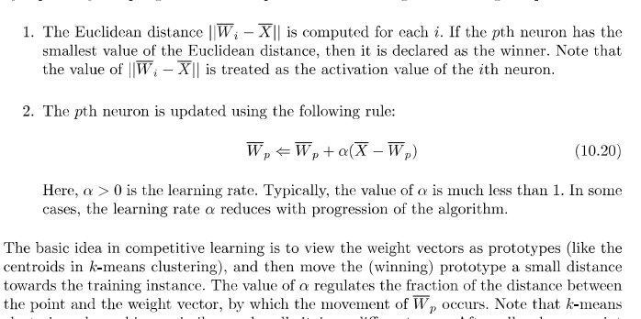

**Vector Quantization**

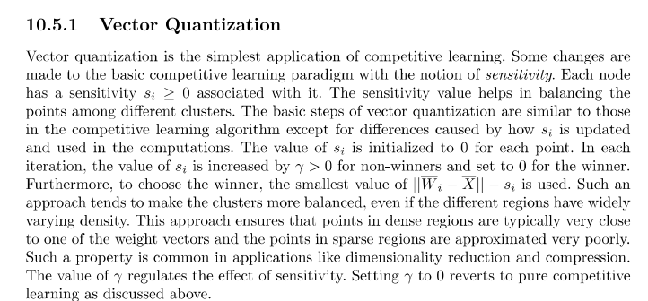

**Kohonen Self Organizing Map**

**What is K-SOm**

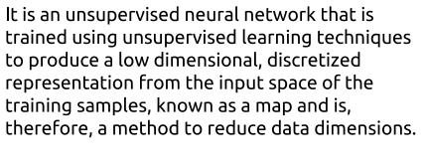

**Read the following to get basic understaning**

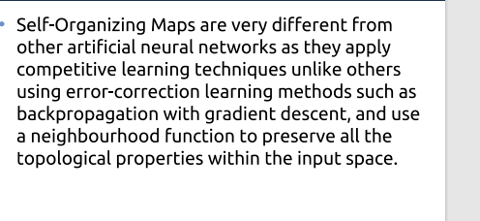

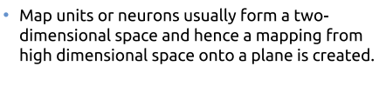

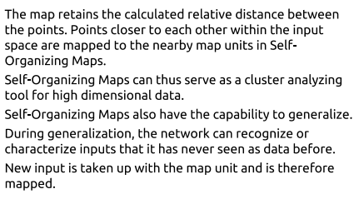

**Explain about K-SOM (From text book)**

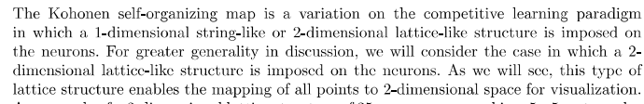

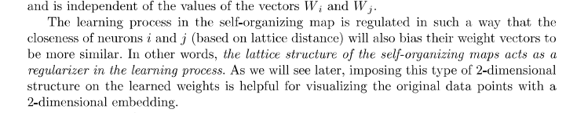

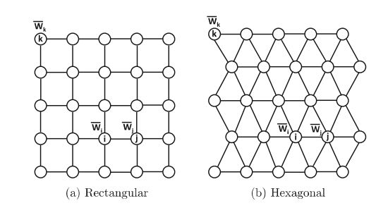

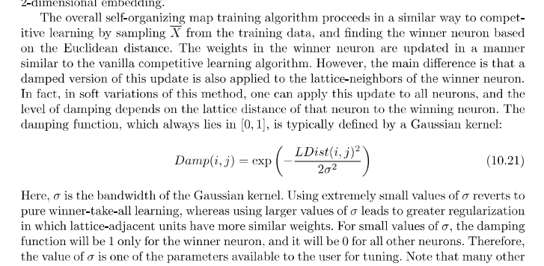

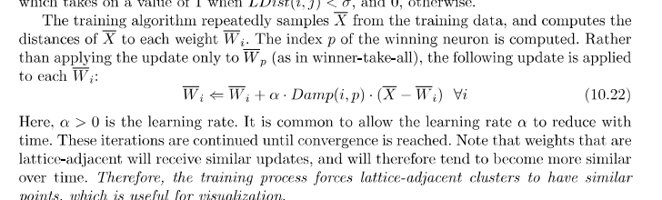

**Limitations of Neural Networks**